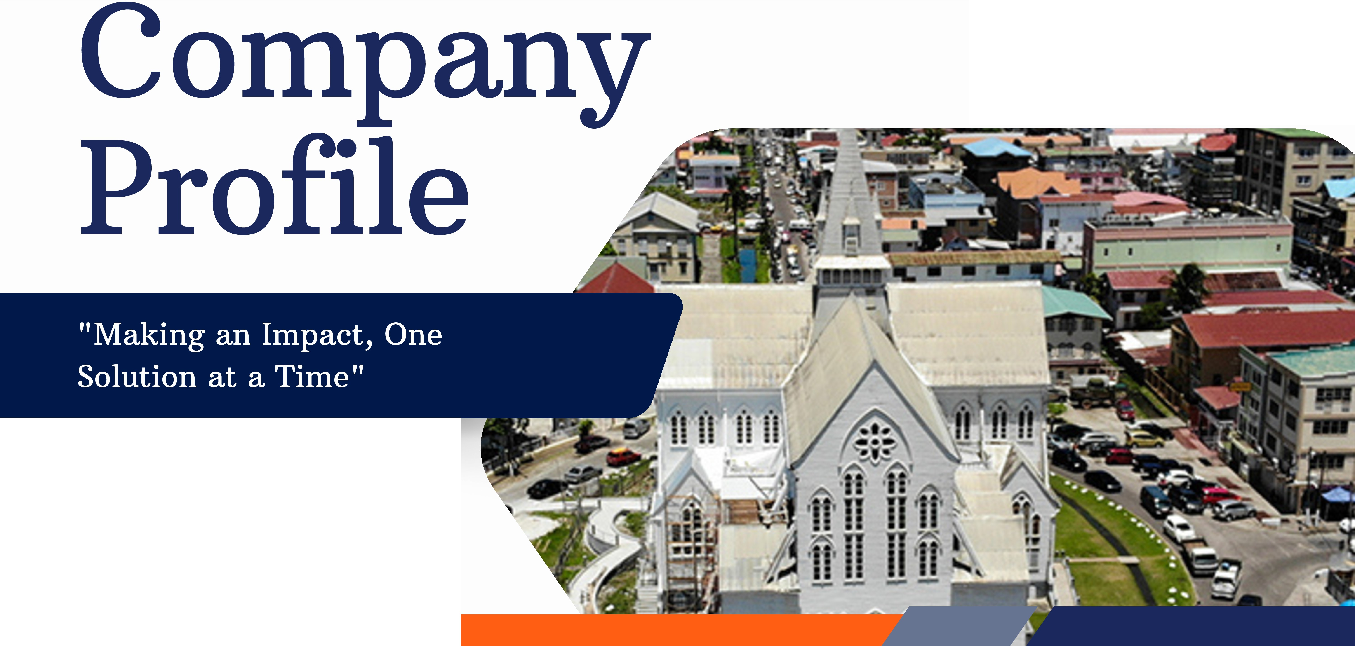

***1111***

-.;•·

...•

••••••••

I

Business Solutions

***11112025***

# elcome to

***1111***

**Impact Business Solution s_**



We are a boutique marketing and business development agency, dedicated to fueling business growth through innovation and excellence. Our expert team provides tailored services to meet each client's unique needs, making us your go-to strategic partner for achieving success in marketing and business development. Our proficiency and creative solutions stimulate growth, secure market share, and enhance your brand.

###### Charlyn Miller

Founder - Business Development Executive

**Page 1** I

# Company Vision

& **Mission**

..•�• ••-

...

.-�•·

I

**Business Solutions**

**D Vision**

"To be a trailblazing force in the world of marketing and business development, driving businesses to unparalleled growth and success through innovative solutions.'

**D Mission**

To unlock the full potential of every business we serve by crafting strategies that inspire growth, innovation, ana meaningful market impact.'

**Page 2** I ***1111***



# yYou Should Choose Us?

***1111***



Our consultants bring extensive industry experience and a commitment to excellence.



We design strategies specifically aligned with each client's unique goals.

(0

**Client-Centric Approach**

We prioritize open collaboration and communication, ensuring you're an integral part of the process

A history of delivering impactful results across diverse projects



**Page 3** I

***1111***

....·�.··

....



•• ••

1111 T

**Business Solutions**



Since 2021, Impact Business Solutions has been empowering businesses to grow both online and offline through innovative marketing and business development strategies. We provide a wide range of services that allows us to have a holistic approach to your business growth.

Our target market includes startups, small-to-medium enterprises, and established businesses looking to enhance their brand presence, improve customer engagement, and increase revenue.

we are committed to helping businesses achieve success by promoting their brands, creating meaningful connections and providing solutions to optimize operations.

***1111***

## Our

### Services

***1111***

Experience a full spectrum of services that position us as your ultimate one-stop hub for administrative, marketing, and management support, empowering your business to thrive and grow!

#### Administrative Support Digital Marketing

Page 5 I

* Business I Company Registration
* Compliance Services
* Document Preparation
* Business Plans & Proposal Writing

#### Business Development

* + Government Tender Completion
  + Training and Development Programs
  + Sales Strategy Development
  + HR Recruitment Support
  + Brand Development
* Social Media Management
* Sponsored Ads
* Content Creation & Graphic Design

#### Event Management

* Product Launches
* Event Marketing and Promotions
* Trade Shows and Expos
* Corporate Event Planning
* Company Anniversary Celebrations
* Vendor and Venue Management



We elevate your corporate presence by expertly managing your profiles and curating captivating content that drives engagement and grows your fanbase across social media platforms like Facebook, Instagram, Linkedln, and TikTok. Let us transform your online identity into a vibrant community!



**amima**

17

MONDAV

***r***

...

(9..

� -

***r***

*�*

*�*

*�*

,.

**a**

***r***

*�*

*�*

*�*

,.

... M,.

***r***

***,r***

\.

•

*�*

�

* + -� �



Page&







From conceptualizing your business branding to designing the branding elements, our team creates unique brands that make your business stand out from your

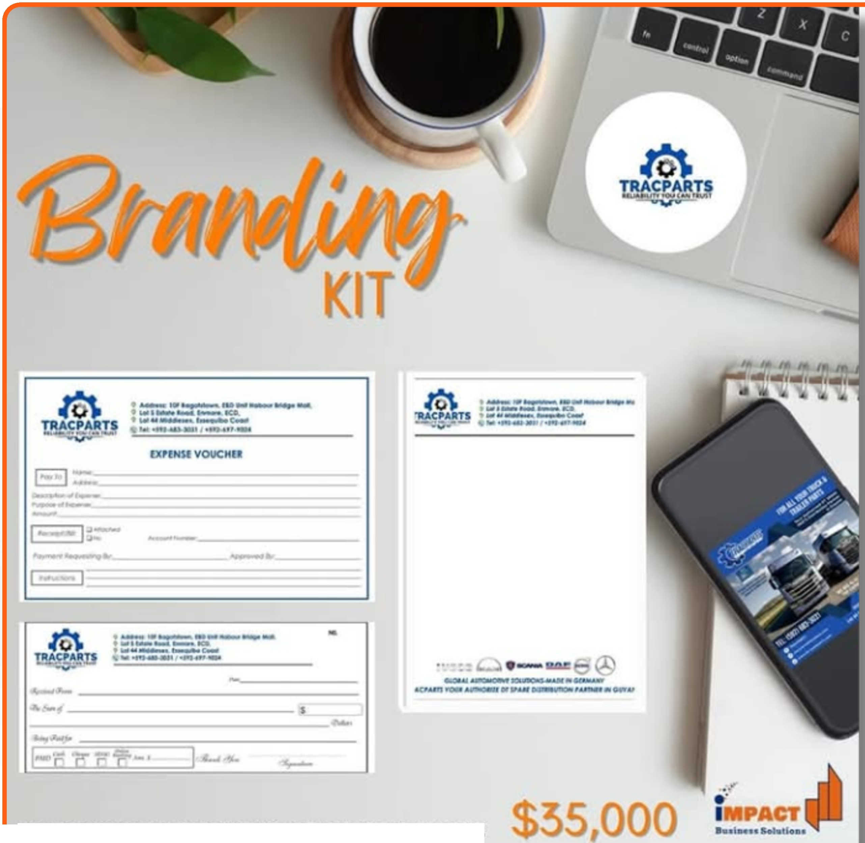

ALL DESIG S PLUS P I Tl G OF CARDS BOOKS

competitors **Page 7**



*SERVICES*

We provide comprehensive compliance and registration services to support businesses of all sizes. Our offerings include assistance with GRA (Guyana Revenue Authority) and NIS (National Insurance Scheme) compliance, as well as business and company registration. We ensure your business meets all legal requirements, helping you operate smoothly and confidently within the law.

Pauea

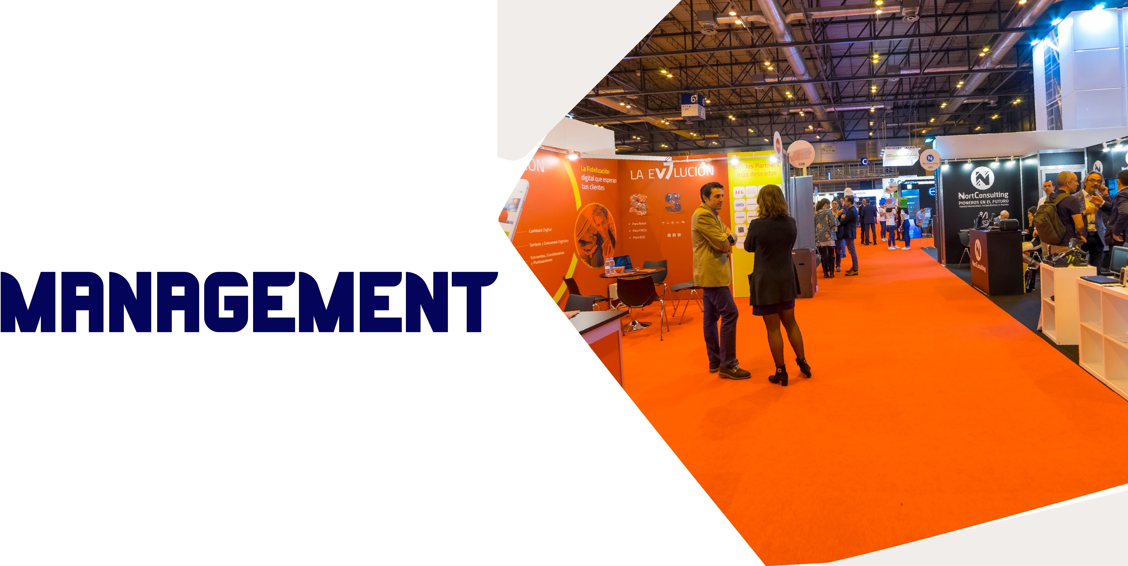



"DELIVERING MEMORABLE EVENTS FOR EVERY OCCASION"

We provide professional event planning and management services, handling every detail to create memorable and seamless experiences. From concept to execution, we ensure your event is tailored to your vision and delivered with excellence.

**Page 9**

# at Make Us Different?

Dedicated Support: Our clients benefit from ongoing support and consultation throughout the implementation process, ensuring smooth transitions and sustained success.

Customized Strategies: Rather than a one-size-fits-all solution, we take the time to understand our clients' specific challenges and goals, crafting tailored strategies that yield impactful results.

Focus on Measurable Outcomes: We prioritize results that can be quantified, enabling clients to see the tangible impact of our solutions on their business performance.

***1111***



**Page 10 I**



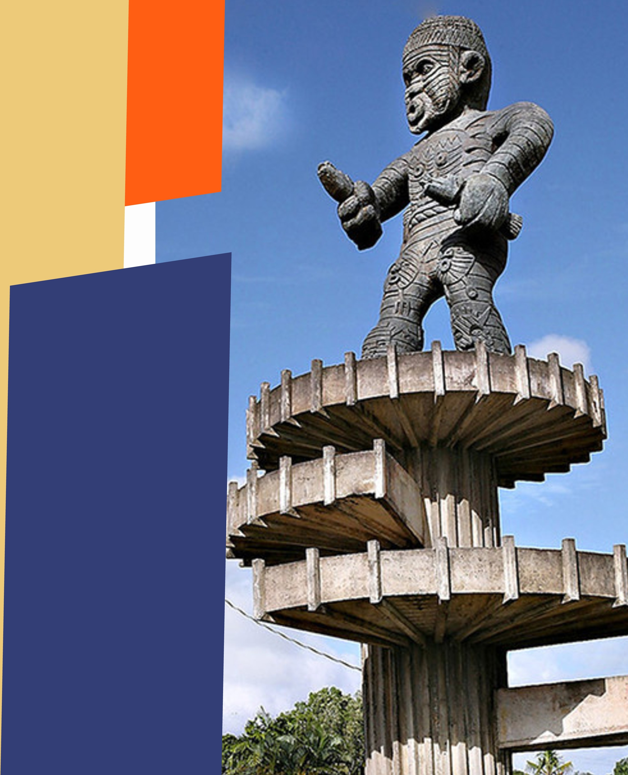





To propose the best ideas, create the finest experiences, and build a lasting impression w"ith your brand through our expertise and innovative solutions.

##### Page 11

 

GENERAL CONTRACTORS TOOLS. WELDING & PROCUREMENT



**HORIZON HOTEL**

NAZEEM'S **Hv���-'**✓**FLEX**

**JEWELRY** HOSE ANO OUCT��l�ICULTURE ANCODNSTRUCTION

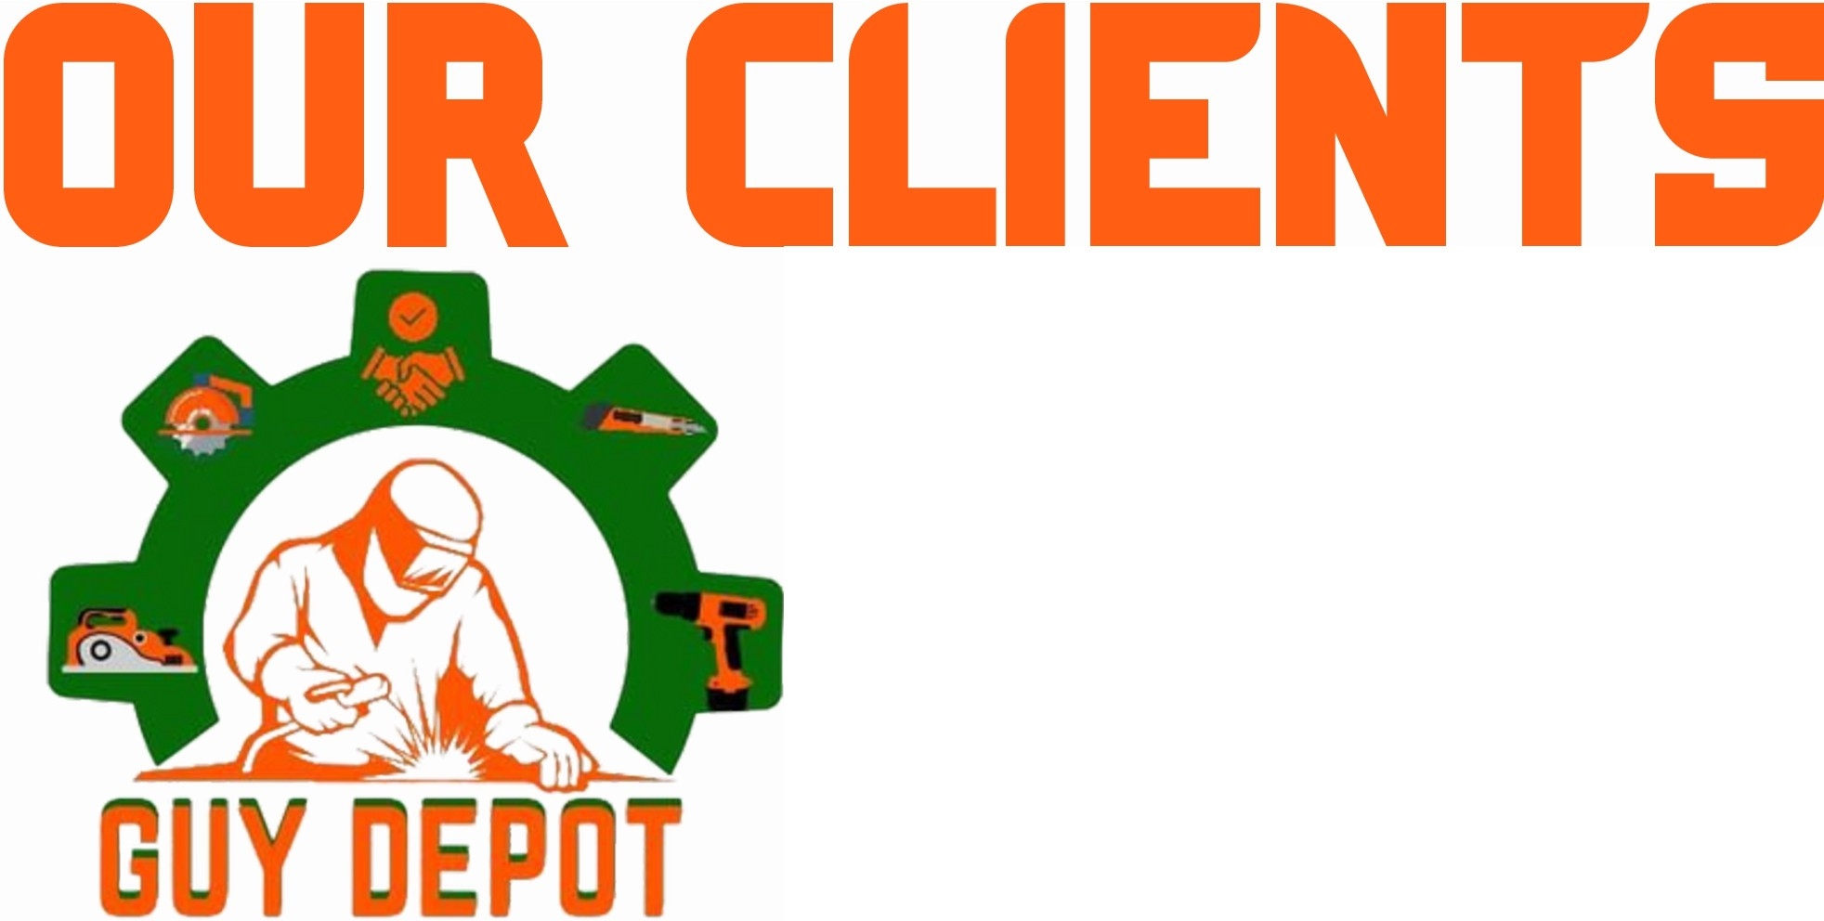

*._(Q/7�Paa 3kr!f-6o/¥Cl/n?*



v**;**�**;/J.i**

**AKAMAI INCORPORATED**

RELIAa1L1TY You cAN TRusr Listing in Guyana

**VVV** PROPERTY MANAGEMENT

**TRACPARTS**

WINDJAMMER

International Cuisine & Comfort Inn

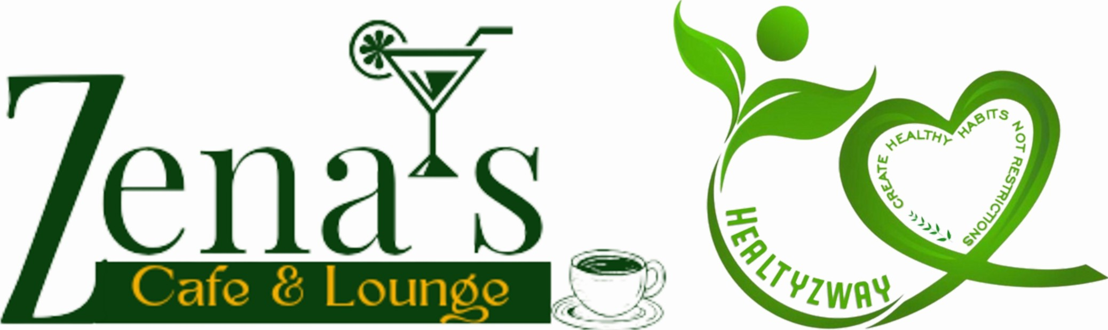Electrical 6 General Store Inc.

I

**Please Get In Touc ith Us**

� +592 679 2338

**Business Solutions**



imi [marketingimpact20@gmail.com](mailto:marketingimpact20@gmail.com) @impactbusinesssolutions

***1111***

....-•��•.•.•-··

IM T

Business Solutions





*J*



***1111***

 